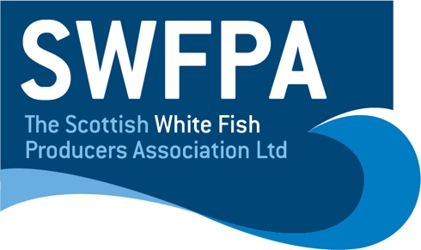

Fisheries Policy Officer (Marine Science)

SWFPA are inviting applications to join the SWFPA team as our Fisheries Policy Officer (Marine Science).

Scottish Whitefish Producers Association (SWFPA) is a trade protection body representing the interests of 250 Scottish vessels operators and their crews. We are seeking an energetic, dedicated individual to work as part of a small but focussed team.

Educated to degree level or equivalent, the successful candidate will be a resourceful self-starter, able to operate effectively alone or as part of industry or multi-disciplinary teams.

Frequent travel within the UK and overseas is expected, a driving licence and the willingness to work out-with normal hours are required. Our office base is Fraserburgh, but the successful applicant may operate remotely.

For further information contact Lianne Morenc at lianne@swfpa.com

